Q1

1. Install protobuf

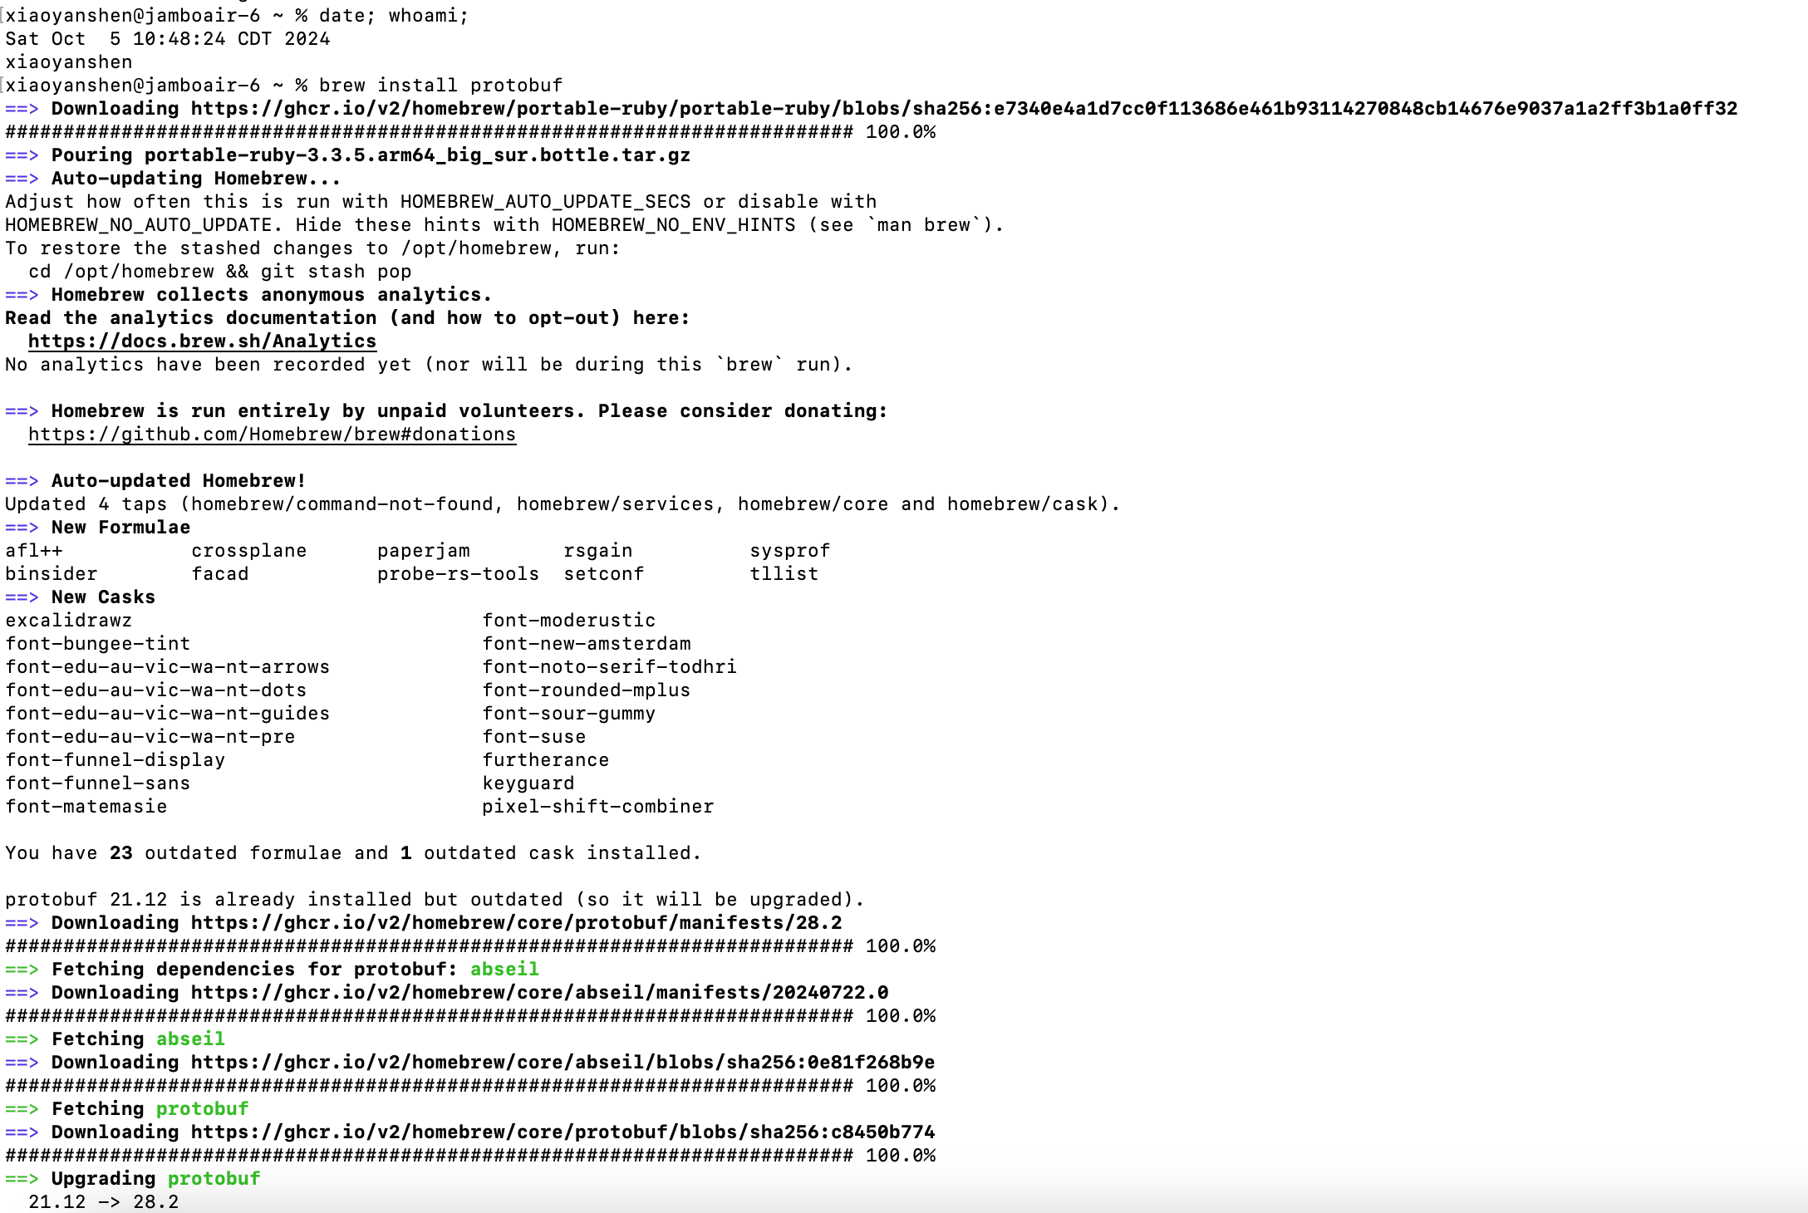

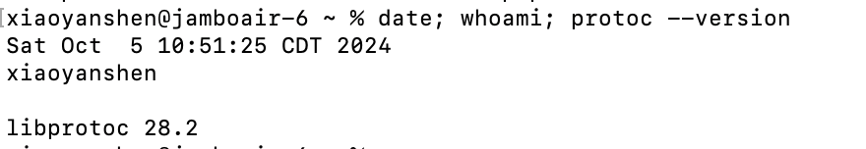

1. Install the protocol compiler plugins for Go

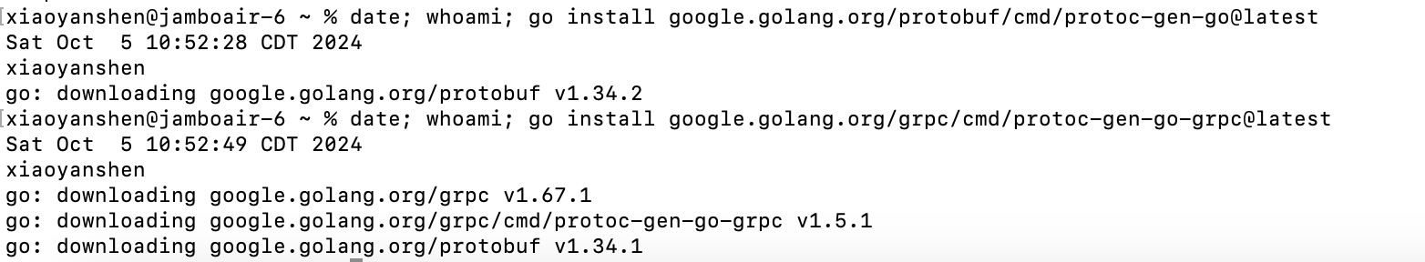

1. Update your PATH so that the protoc compiler can find the plugins

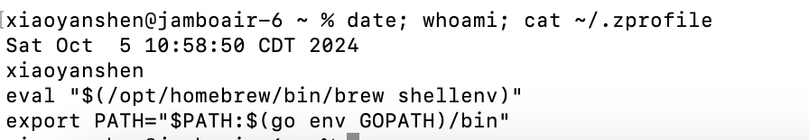

1. Get the example code

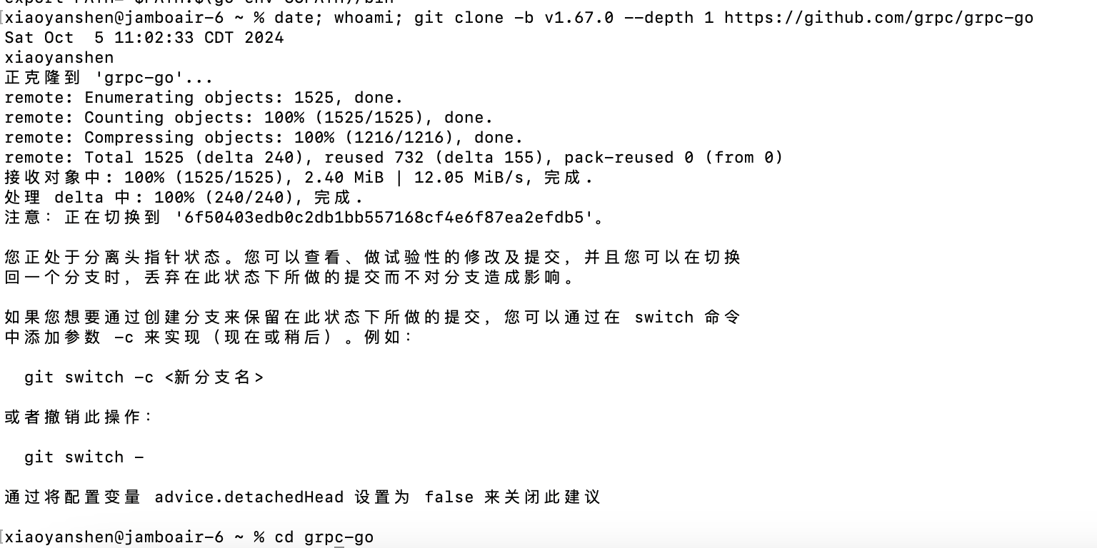

1. Run the example

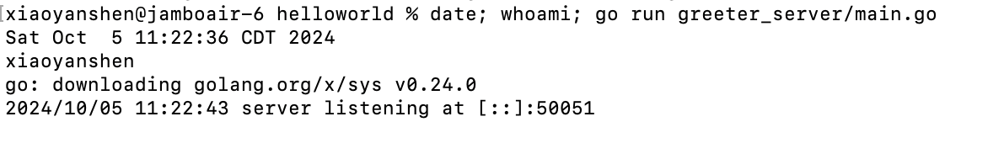

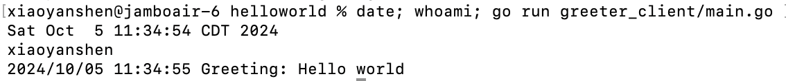

1. Regenerate gRPC code



1. Update and run application

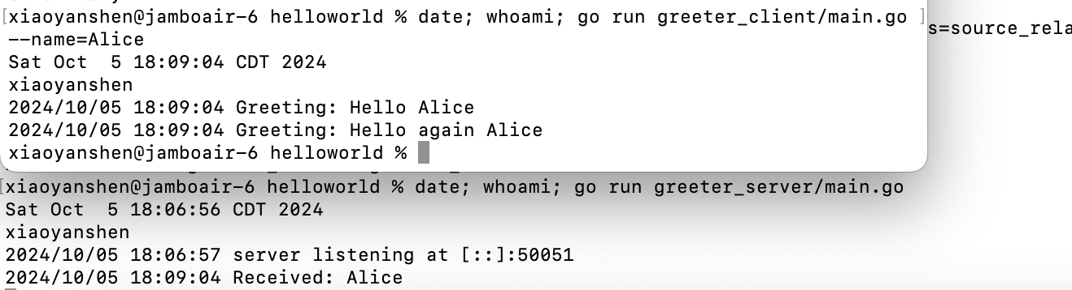

Q4

CASE1: Create a pet in **container** and then search the pet, because of unable to open picture in container, I copy the picture to my laptop and open it.

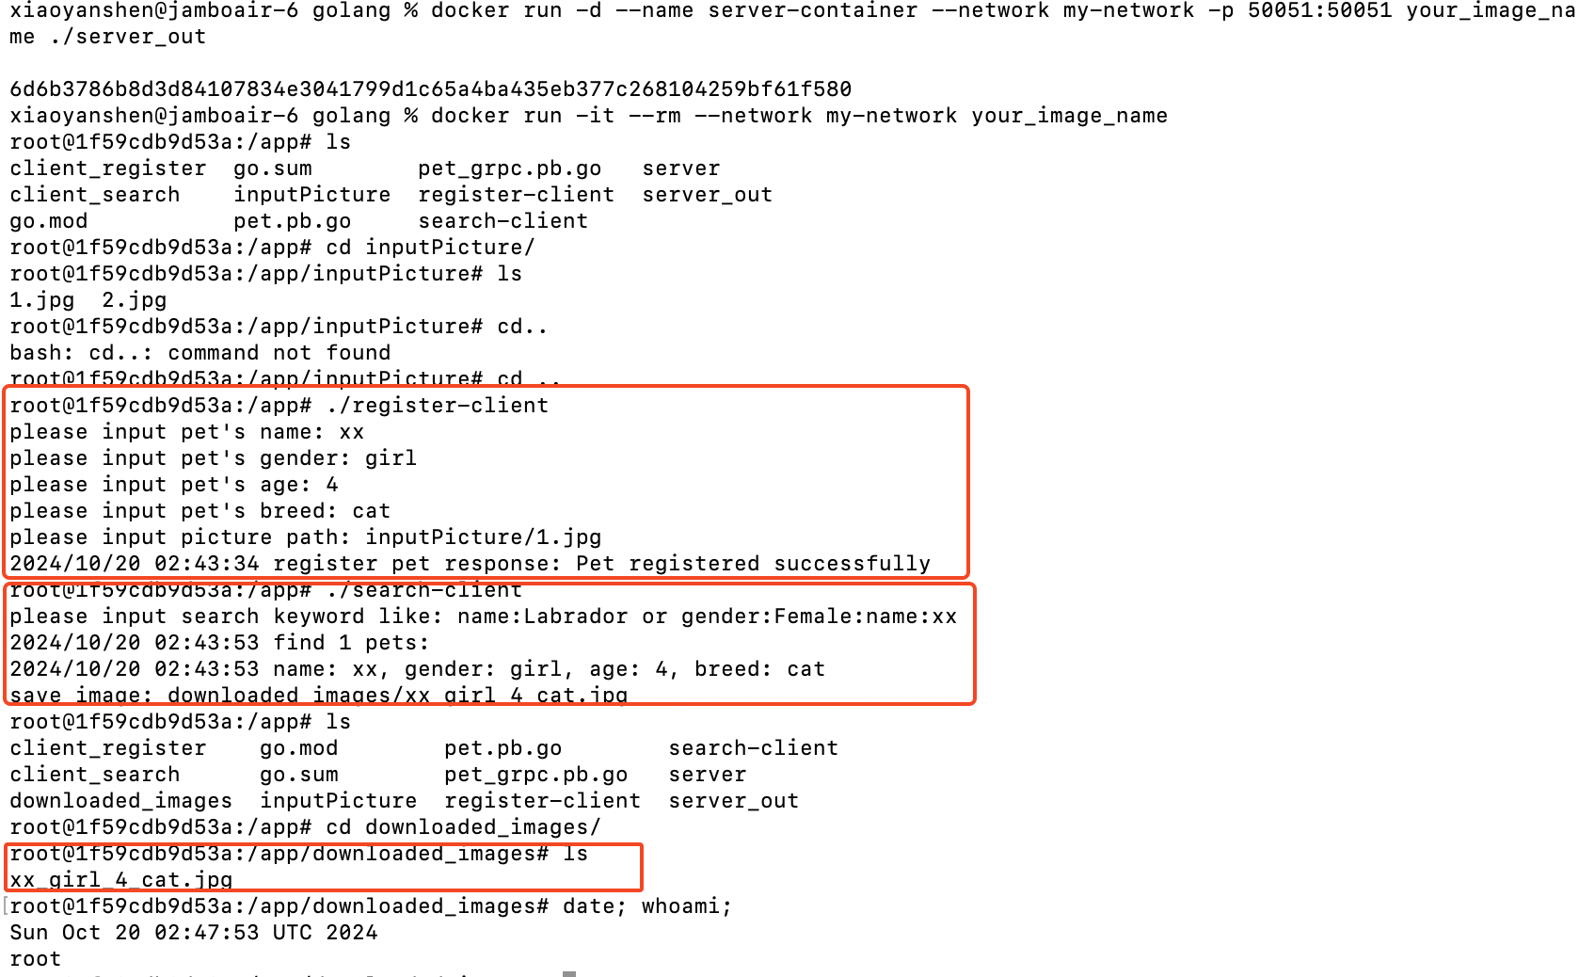

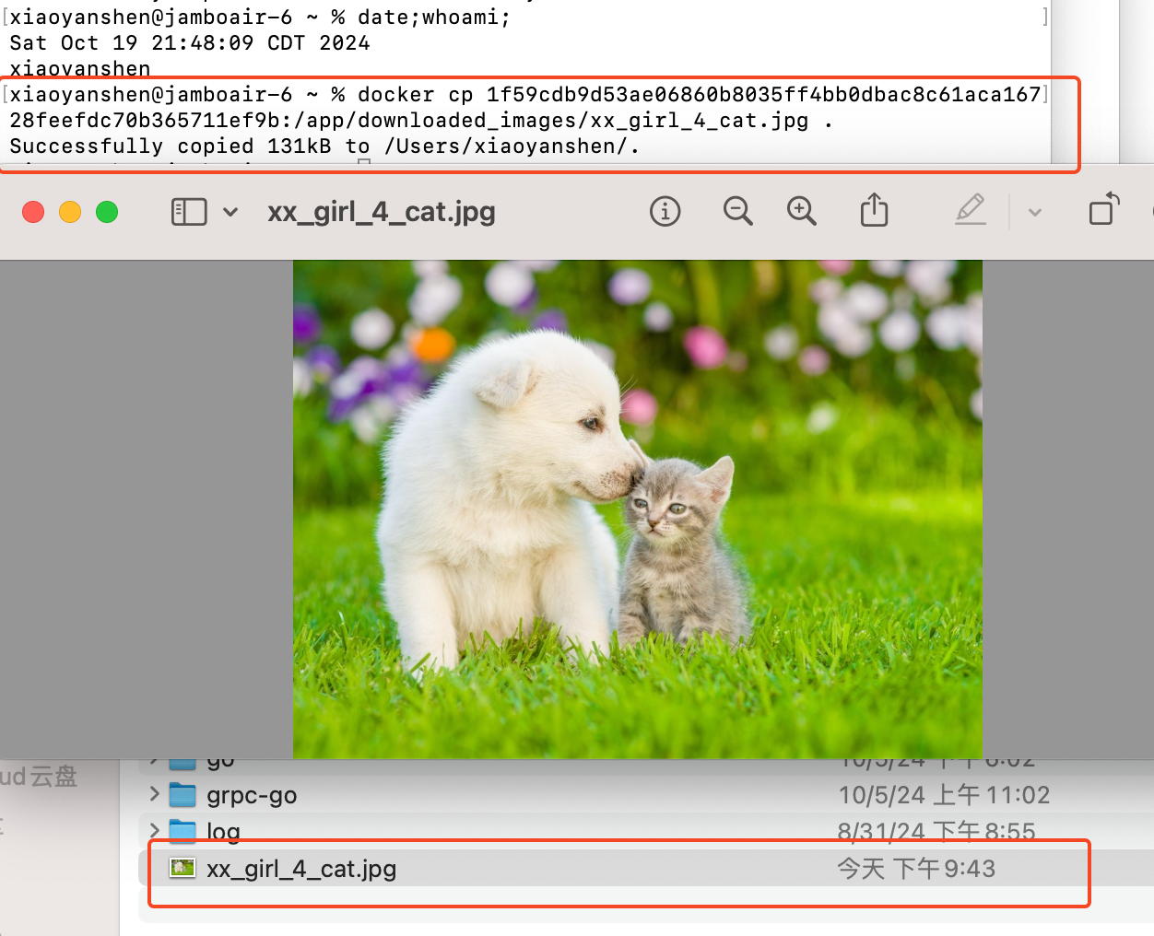

CASE2: Run project in my own environment---- register kate-girl-1-cat and search by name

1. Compile the project

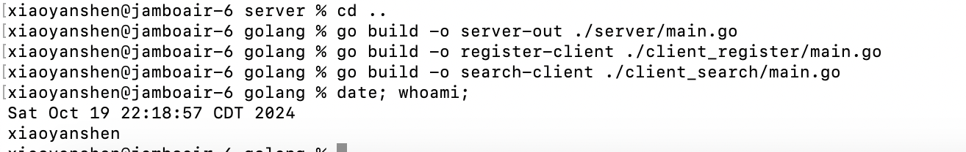

1. Run server

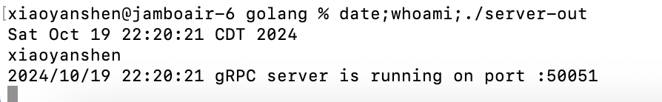

1. Run client register kate-girl-1-cat and search by name

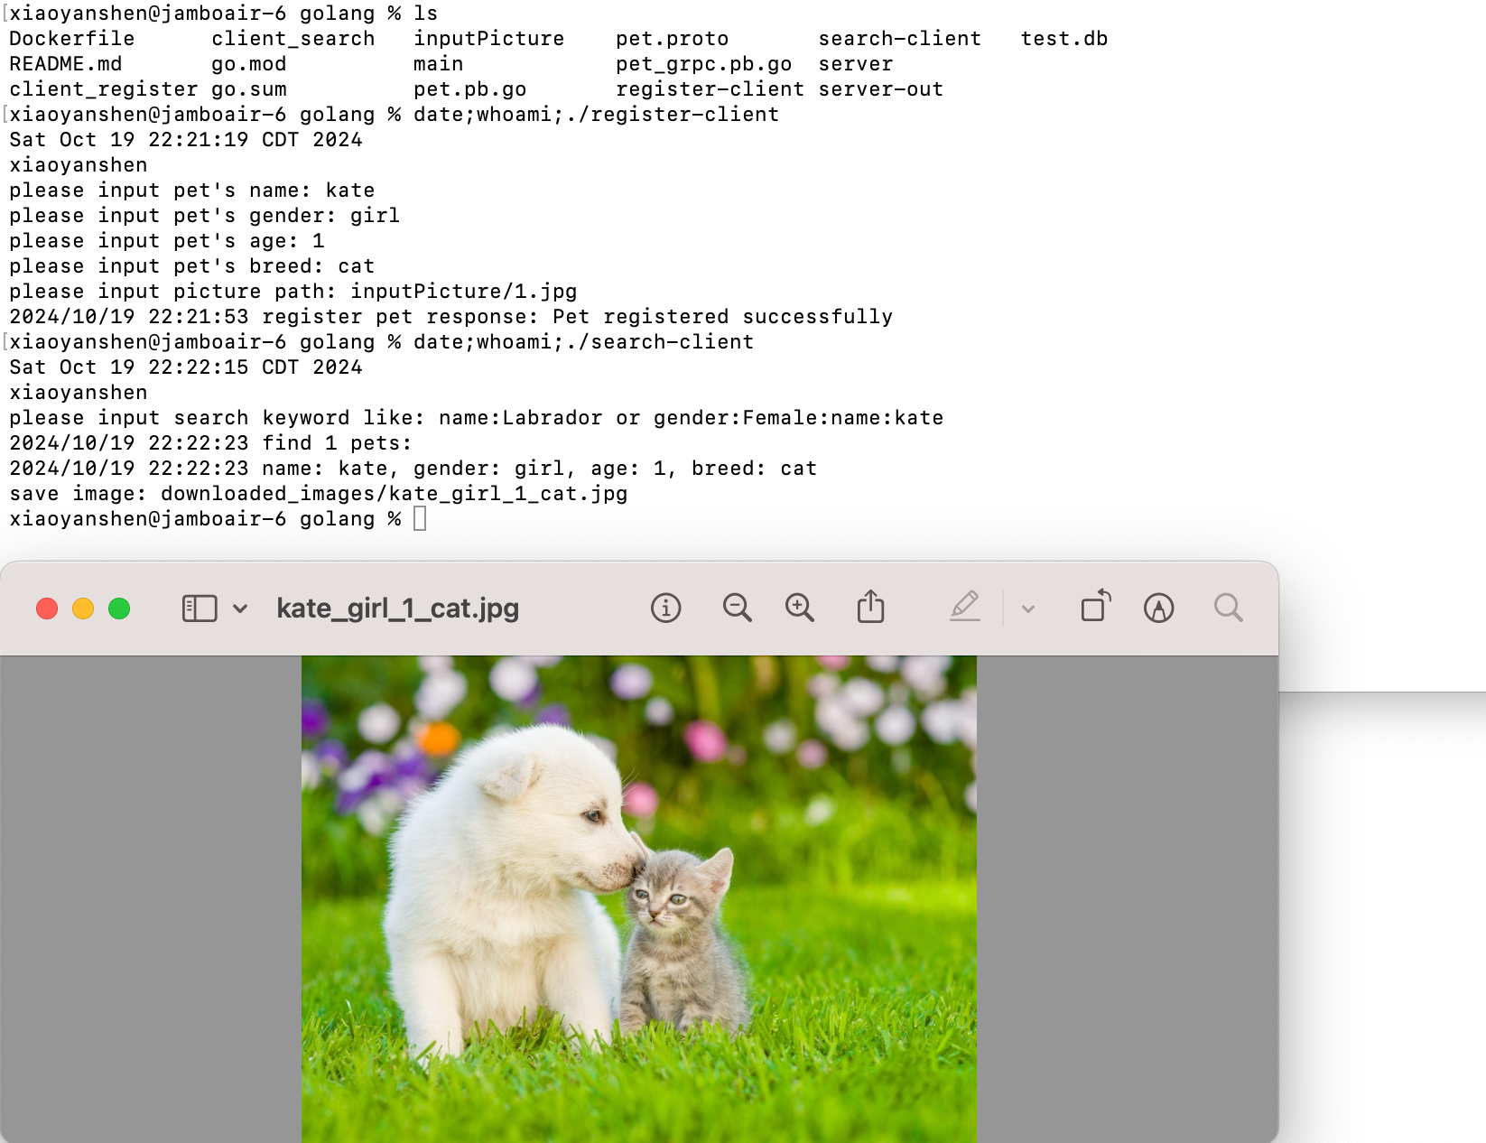

CASE3: Run project in my own environment----register kate-boy-2-dog and search by name

The result show two pets found and show two pets’ picture

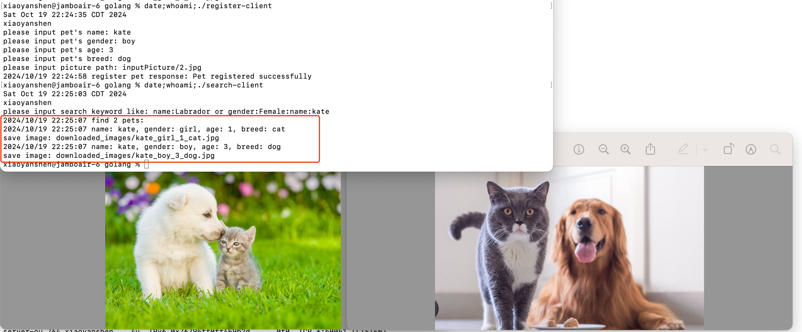

CASE4: Run project in my own environment----test search by other conditions

Search by age

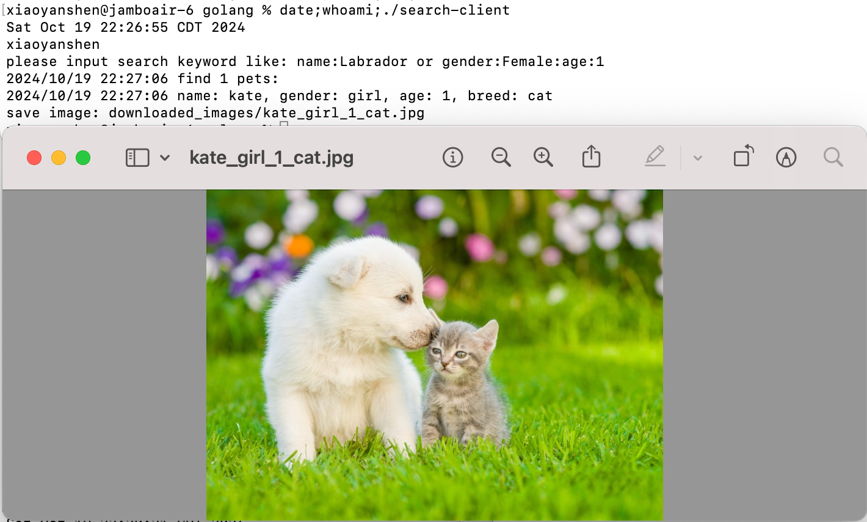

Search by gender

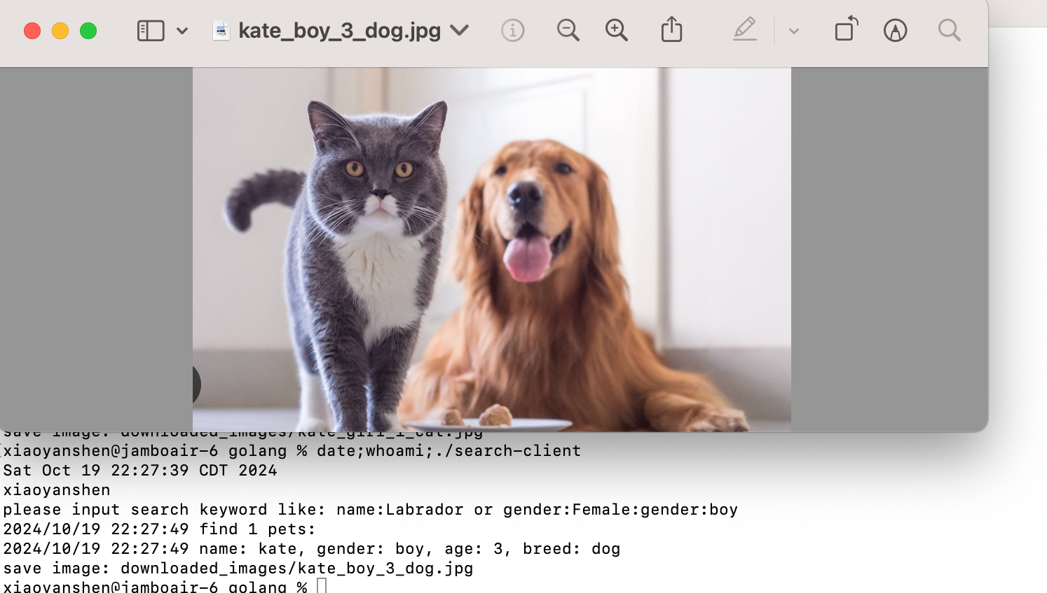

Search by breed

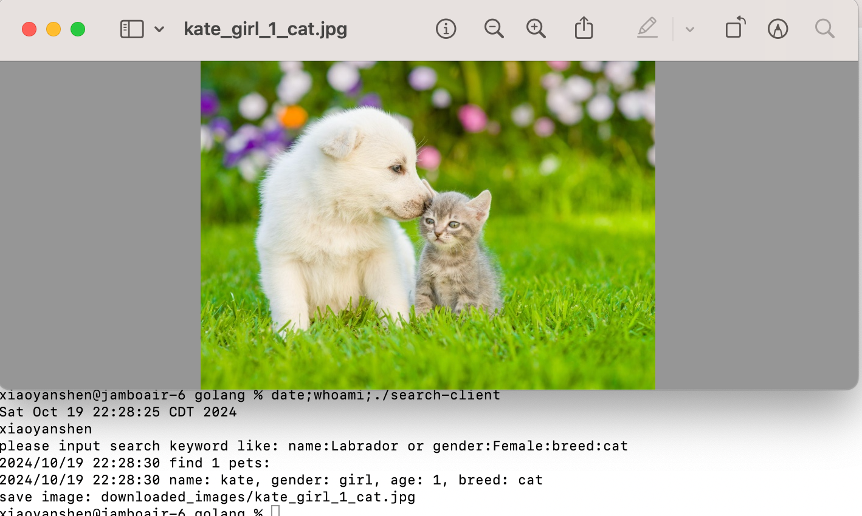

CASE5: Run project in my own environment----test using python client call Golang server

